Required Practical Activity:
Electrolysis

Note:
This resource is designed as a review of the required practical activity, covering all possible skills that could be developed through the investigation. This resource can be adapted to suit the needs of your class, depending on which skills your class need support with.

In this investigation we will use a low voltage power supply to pass a current through two different salt solutions.

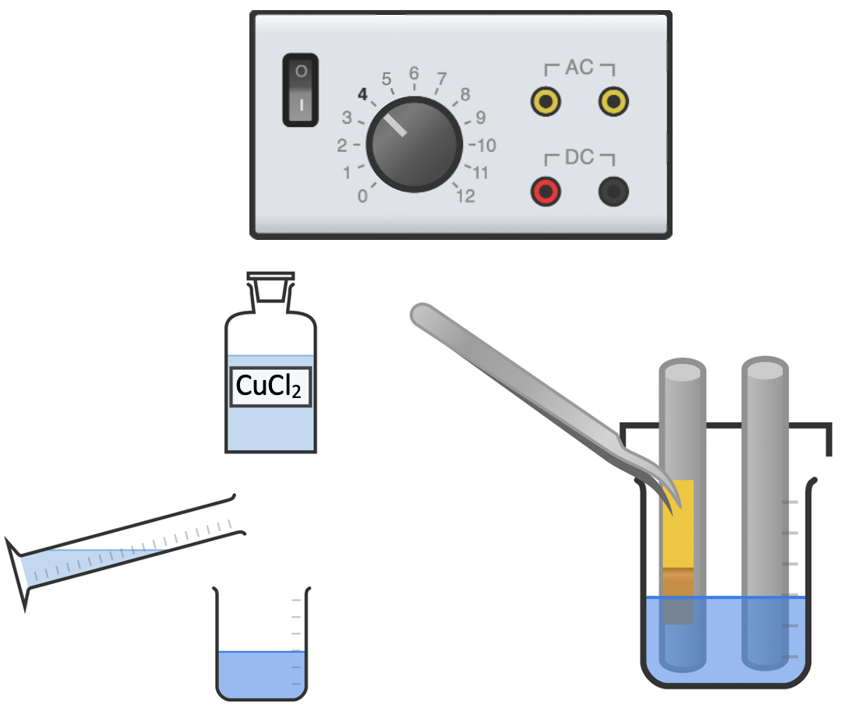
Required equipment diagram

- Electrolysis
- What is electrolysis?

- Hazards:
- What are the chemical hazards present in this practical?

- What other hazards are present in this experiment?

- Equipment:
- What is the name given to the positive electrode?

- What is the name given to the negative electrode?

- Why is it important to ensure the two electrodes do not touch one another?
- Why is it important to rinse the equipment before repeating the experiment with sodium chloride solution?
- Why is it important to keep the voltage below 4 V?
- List the following steps of the method in the correct order:
- Hold a small piece of blue litmus paper in the forceps and position this in the solution next to the positive electrode (anode). Use any change in its appearance to identify the element formed and record this in your table.
- Pour 50 ml of copper (II) chloride solution into the 100 ml beaker.
- Set the power supply to 4V and switch it on.
- Connect the two graphite rods to the power supply using the crocodile clips and 4mm leads.

4. Results
Solution | Positive electrode (anode) |  |  | Negative electrode (cathode)
Solution | Observations | Element formed | State | Observations | Element formed | State
Copper (II) chloride | Bubbles of gas  Bleaches blue litmus paper white |  |  | Brown/red solid coating on rod
Sodium chloride | Bubbles of gas  Bleaches blue litmus paper white |  |  | Bubbles of gas (more rapid production)

- Analysis:
- Complete the above results table.
- Write out the chemical equation for what is happening at the cathode during electrolysis of copper sulfate.
- Write out the chemical equation for what is happening at the anode during electrolysis of copper sulfate.
- During the electrolysis of sodium chloride, why is hydrogen formed at the cathode instead of sodium?

